Infosys Springboard Virtual Internship 6.0 Completion Report

Team Details <Do not mention any personally identifiable information like email ID, institute details, mobile phone number etc.>

Batch Number: 1 SmartStock Inventory Optimization for Retail Stores
Start date : 10-11-2025
Names:
- Rudrakshi Jaiswal
- Varsha Pamisetty
- Jyotsana Sai
- K. Deepak Reddy
- Vijay
Internship Duration: 8 Weeks

1. Project Title
SmartStock – AI-Based Inventory Optimization System for Retail Stores

2. Project Objective
SmartStock is an AI-driven inventory optimization system designed to help retail stores efficiently manage stock levels, reduce overstock and stockouts, and improve overall operational efficiency. By analyzing historical sales data, demand patterns, seasonal trends, and supplier lead times, SmartStock predicts future product demand with high accuracy. The system provides intelligent stock replenishment recommendations and visual insights through interactive dashboards and reports. It also generates timely alerts for low stock, excess inventory, and fast-moving items. As new sales data is added, the AI model continuously learns and adapts to changing customer behavior. Supporting multiple store and product categories, SmartStock enables retailers to make data-driven inventory decisions, minimize losses, and maximize profitability.

3. Project description in detail
SmartStock is an intelligent inventory optimization solution developed to address common challenges faced by retail businesses such as overstocking, understocking, and inefficient inventory planning. The project leverages Artificial Intelligence (AI) and Machine Learning (ML) techniques to analyse historical sales data, identify demand trends, and accurately forecast future stock requirements.
The system collects and processes sales transactions, product details, supplier information, and inventory movement data. Using data preprocessing and classification techniques, products are grouped into categories such as fast-moving, slow-moving, and seasonal items. Predictive models are then applied to estimate future demand while considering factors like seasonal variations, promotional periods, and changing customer preferences.
A key feature of SmartStock is its interactive dashboard, which provides retailers with real-time insights through charts, graphs, and inventory reports. Store managers receive alerts for low stock levels, excess inventory, and reorder points, enabling timely restocking decisions. The system also helps in supplier planning by estimating optimal reorder quantities and lead times.
SmartStock supports multiple user roles, including store owners, managers, and inventory staff, making it suitable for single-store retailers as well as small retail chains. The AI model continuously improves its accuracy as more data is collected, adapting to evolving sales patterns and market trends.
Overall, SmartStock aims to transform traditional inventory management into a smart, automated, and data-driven process. By combining predictive analytics with a user-friendly interface, the project helps retailers reduce operational costs, improve product availability, and enhance customer satisfaction.

4. Timeline Overview
Week | Activities Planned | Activities Completed
Week 1 | Requirement gathering, problem analysis, and project scope definition | Retail inventory requirements finalised, project scope documented, system workflow planned
Week 2 | Research on demand forecasting models and selection of development tools/tech stack | XGBoost model selected for sales forecasting, tech stack finalised (Django REST Framework, React Vite, MySQL, Python)
Week 3 | Database design and setup for products, sales, and inventory data | MySQL database schema designed and tested for sales, inventory, and product tables
Week 4 | Dataset collection, preprocessing, and feature engineering | Store sales time-series dataset (t4tiana/store-sales-time-series-forecasting) collected, cleaned, and transformed
Week 5 | Model development: Training ML model for sales and demand forecasting | XGBoost model trained and evaluated using historical sales data
Week 6 | Frontend development: Dashboard, graphs, and inventory views | React Vite dashboard developed with inventory status and demand forecast visualisations using Matplotlib
Week 7 | System integration: Backend APIs, ML model, database, and frontend | Django REST APIs integrated with ML model and frontend, forecasting and stock alerts enabled
Week 8 | Testing, debugging, documentation, and final deployment | End-to-end testing completed, bugs fixed, documentation prepared, project deployed successfully

5a. Key Milestones
Milestone | Description | Date Achieved
Project Kickoff | Project kickoff conducted to define SmartStock objectives, inventory optimization scope, system workflow, and individual responsibilities. | 14 – 11 – 2025
Prototype / First Draft | Developed initial prototype including database schema, basic Django REST APIs, and sample sales forecasting output using XGBoost. | 28 – 11 – 2025
Mid-Term Review | Mid-term review conducted to evaluate data preprocessing, ML model performance, backend–frontend integration progress, and improvements required. | 12 – 12– 2025
Final Submission | Submitted the completed SmartStock Inventory Optimisation system with trained XGBoost model, React dashboard, APIs, and documentation. | 26 – 12 – 2025
Presentation | Prepared and delivered the final project presentation demonstrating inventory forecasting, dashboards, and system outcomes. | 02 – 01– 2026

5b. Project execution details
• Requirement Analysis – Analyzed retail inventory challenges, gathered user requirements, defined project scope, and finalized objectives for inventory optimization.
• Technology Selection – Selected Django REST Framework for backend APIs, React (Vite) for frontend, MySQL for database management, XGBoost for demand forecasting, and Matplotlib for data visualization.
• System Design – Designed database schema for products, sales, and inventory, created system workflow diagrams, and planned frontend UI structure.
• Data Collection – Collected store sales time-series dataset from t4tiana/store-sales-time-series-forecasting for training and testing.
• Data Preprocessing – Cleaned and transformed sales data, handled missing values, created time-based features, and structured data for ML model training.
• Model Development – Trained and evaluated the XGBoost model for sales and demand forecasting, tuned model parameters, and validated prediction accuracy.
• Frontend Development – Developed a responsive React dashboard to display inventory status, demand forecasts, and graphs using Matplotlib outputs.
• Backend Development – Built REST APIs using Django REST Framework, integrated the trained ML model, and connected backend services with the frontend and database.
• Testing & Integration – Performed unit testing, API testing, and end-to-end system integration; identified and fixed functional and performance issues.

6. Snapshots / Screenshots
Step 1: Open the SmartStock Application
In this step, the user opens the SmartStock Inventory Management System. The landing screen provides access to various modules through the left-side navigation menu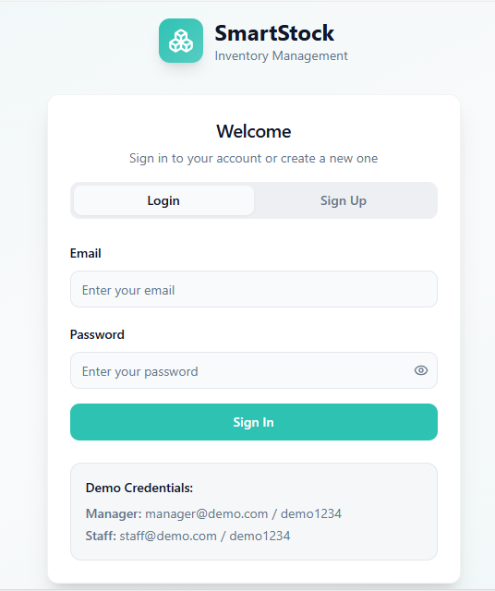
Step 2: Login to the System
The user logs into the application using valid credentials. Role-based authentication ensures that only authorized users such as managers can access inventory functions.

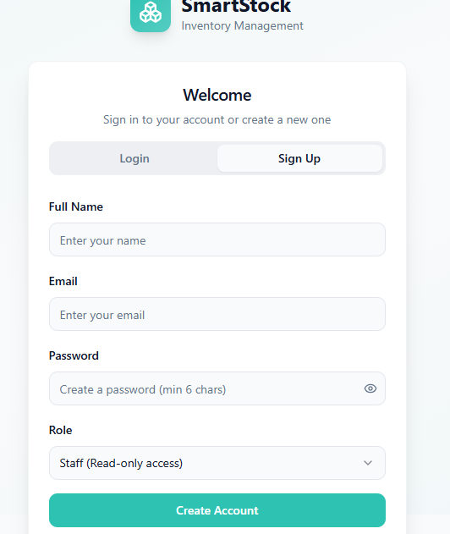

Step 3: Dashboard Overview
After login, the dashboard displays a summary of total products, stores, stock status, and notifications. It provides a quick overview of inventory performance (staff account)

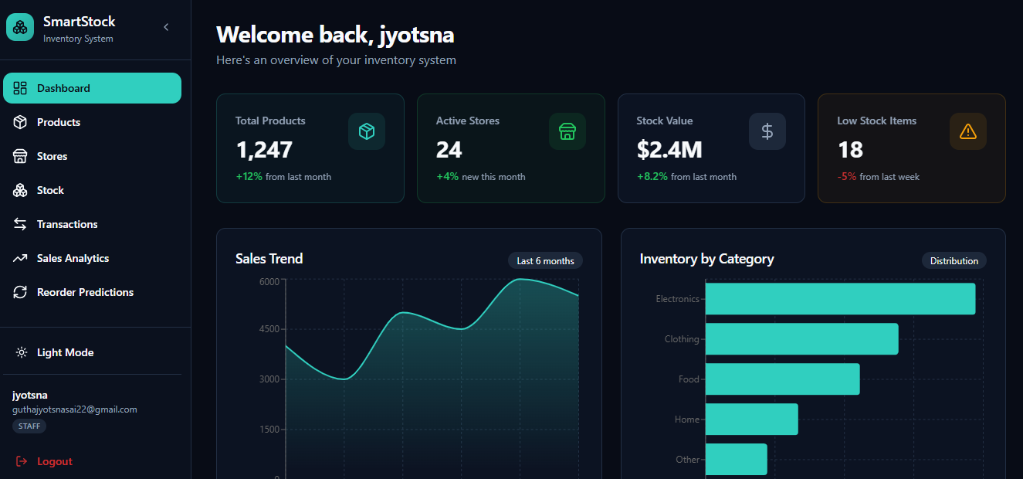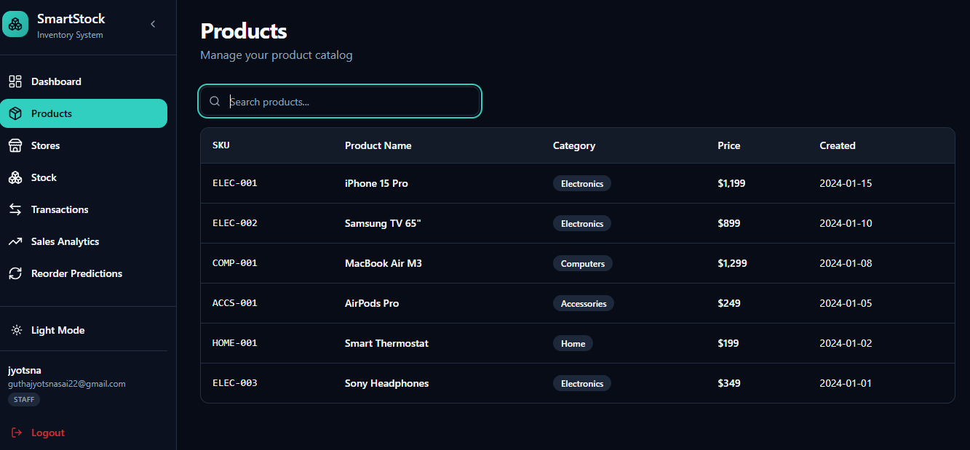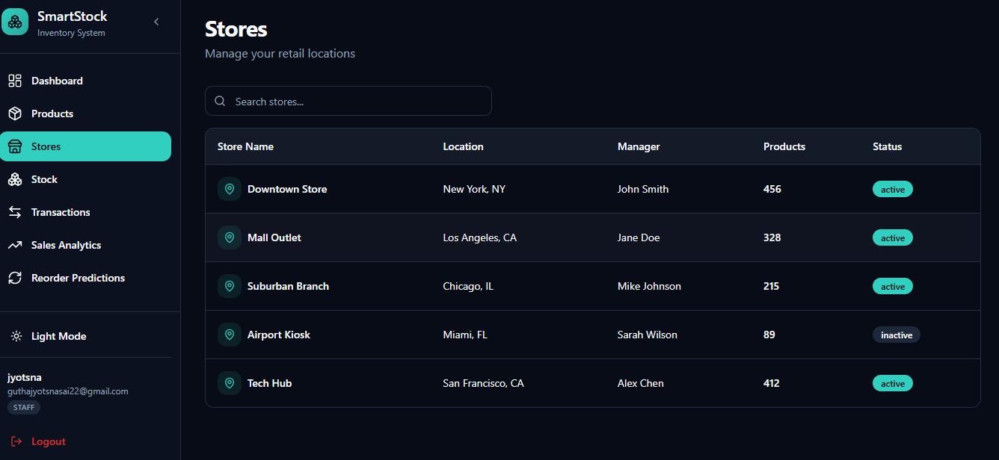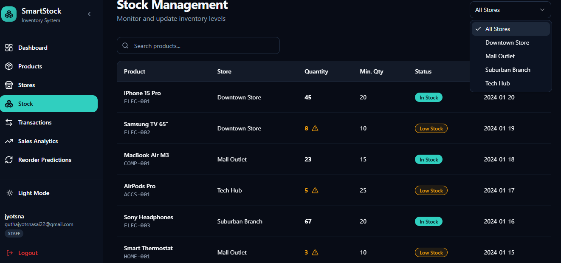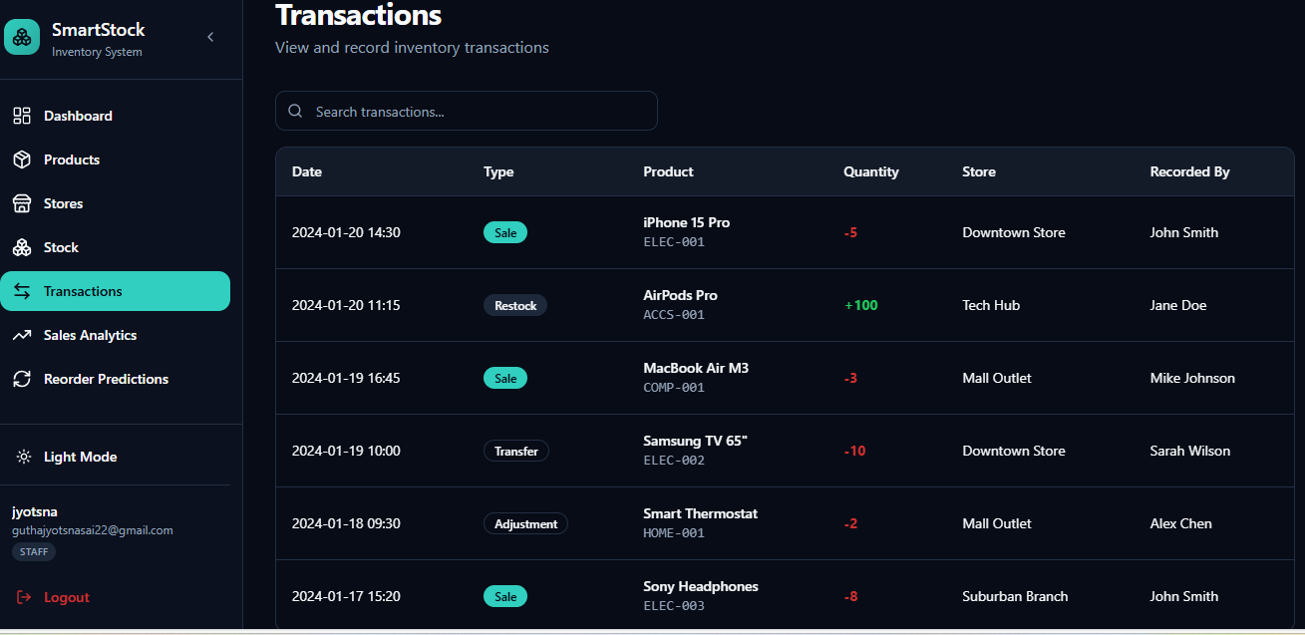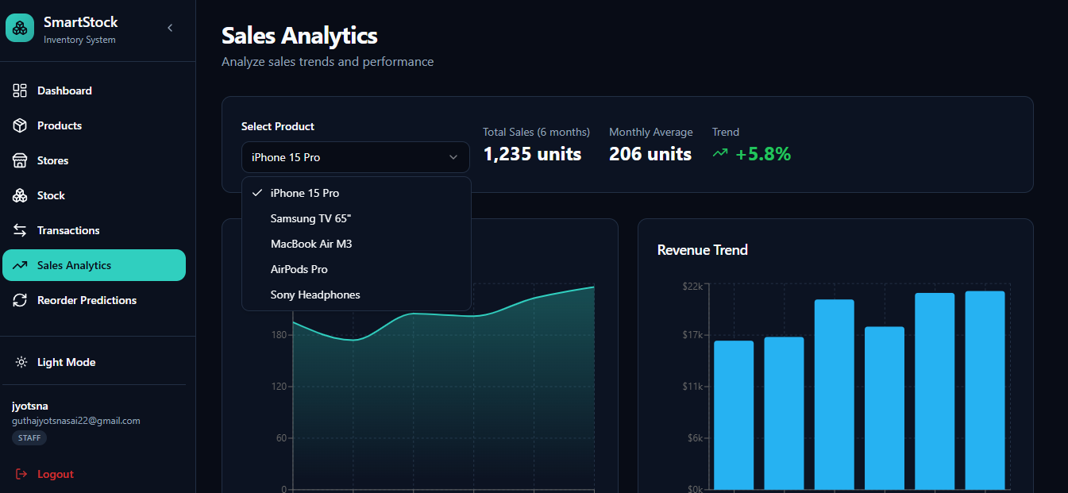
Step 4: Viewing Sales Analytics
This screen shows the Sales Analytics page where users analyze sales trends and performance for different products.
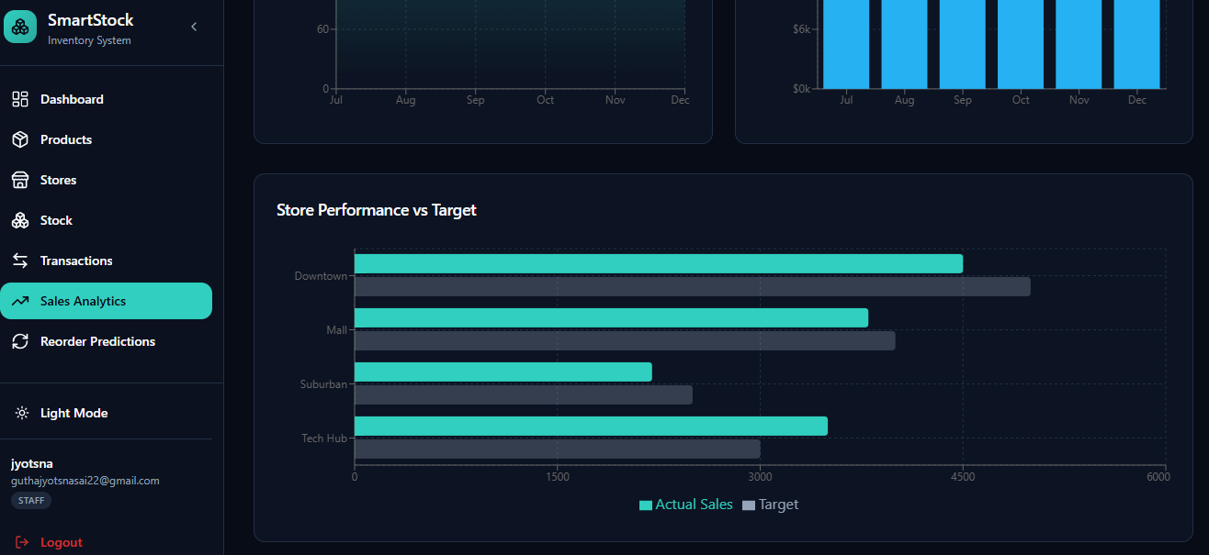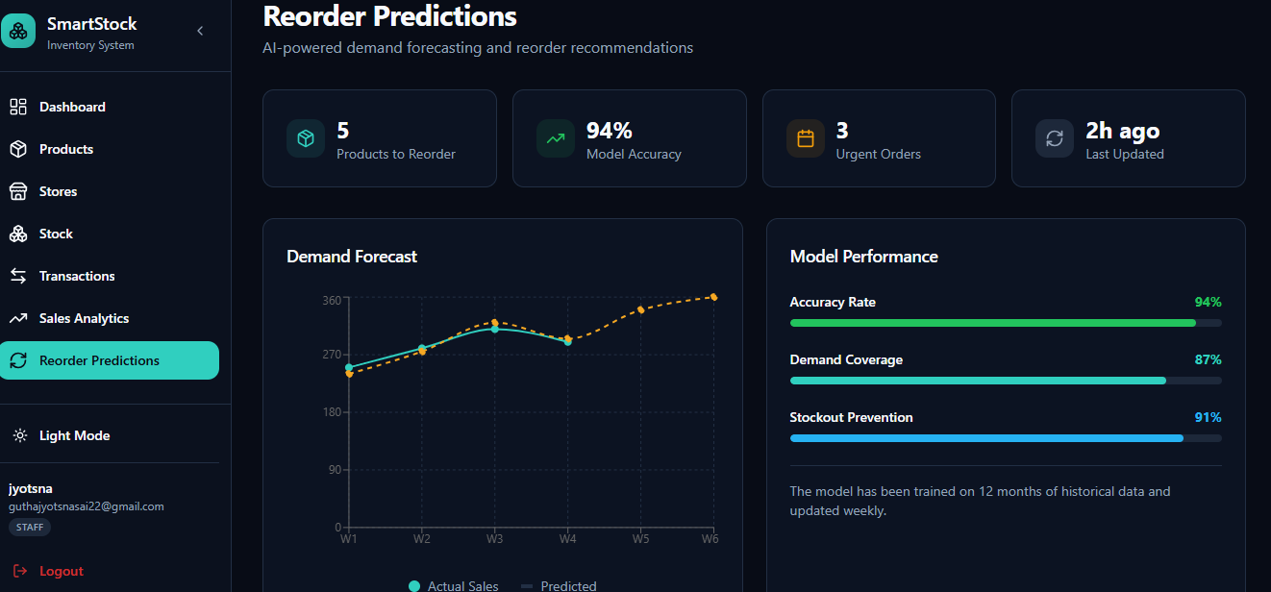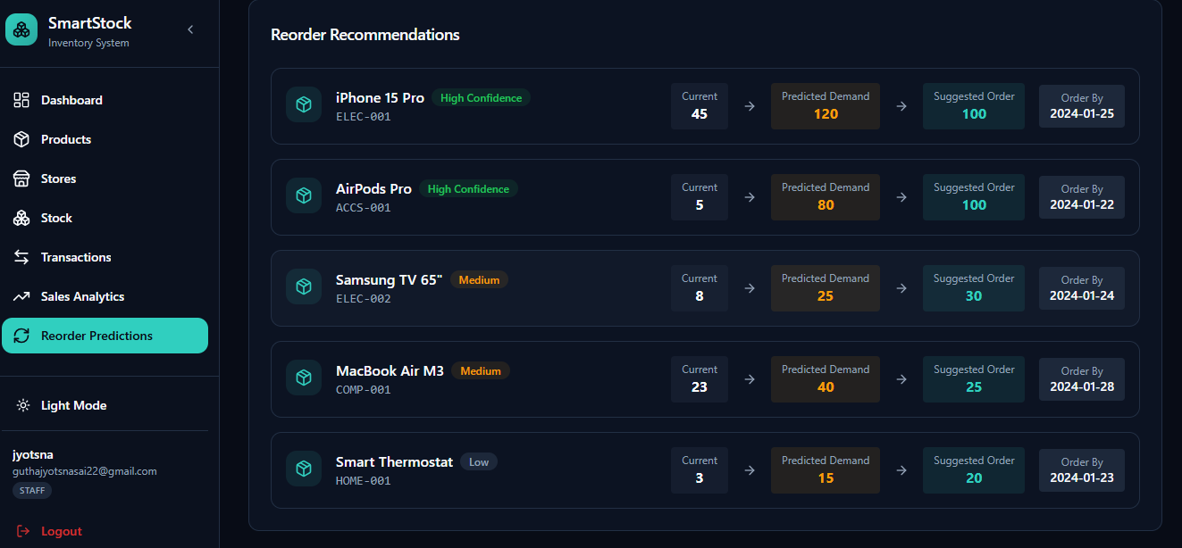
Step 5: Sales Trend Graph
This screen displays the Sales Trend – iPhone 15 Pro line graph, showing monthly sales patterns over six months.

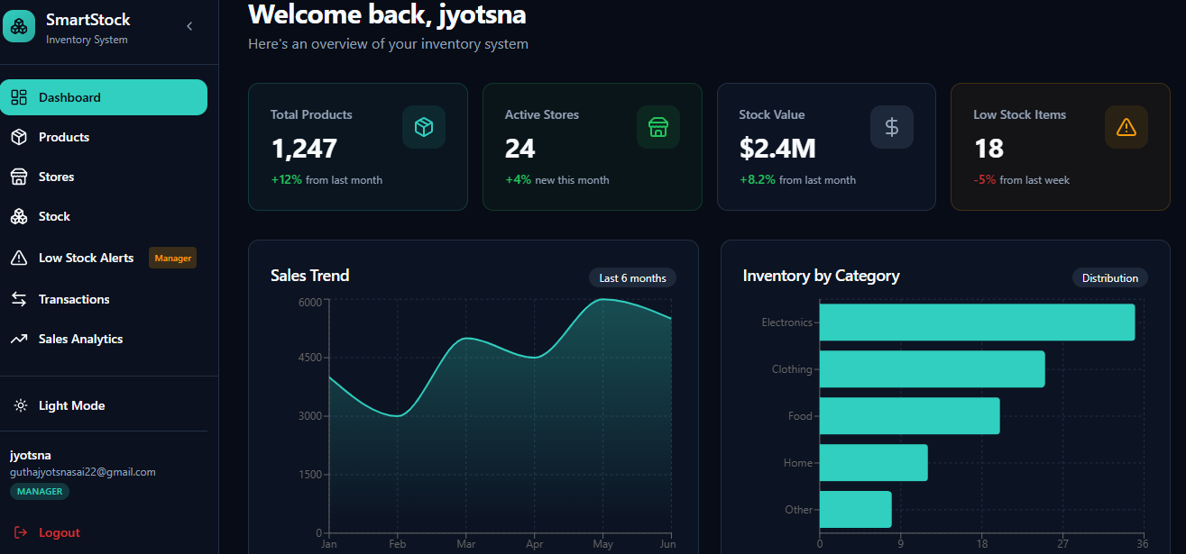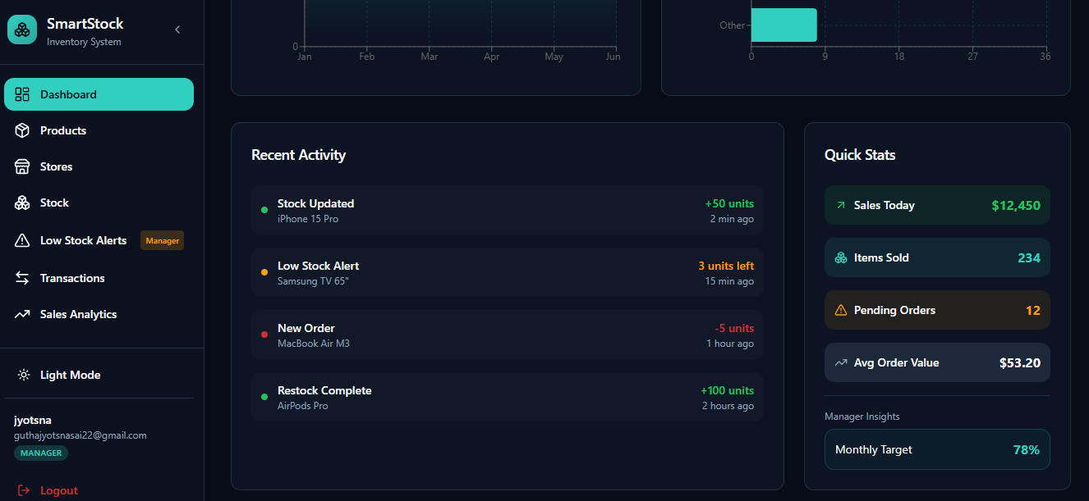
Step 6: Adding a New Product
The user can add new inventory items by entering product details such as name, category, price, and quantity.

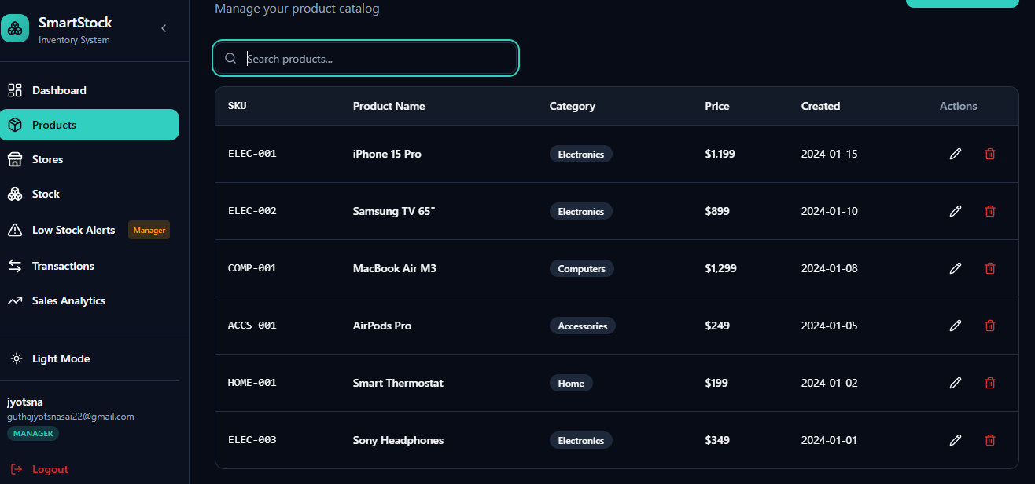

Step 7: Low Stock Alerts
The system generates alerts for products that reach minimum stock levels, helping avoid stockouts and lost sales.
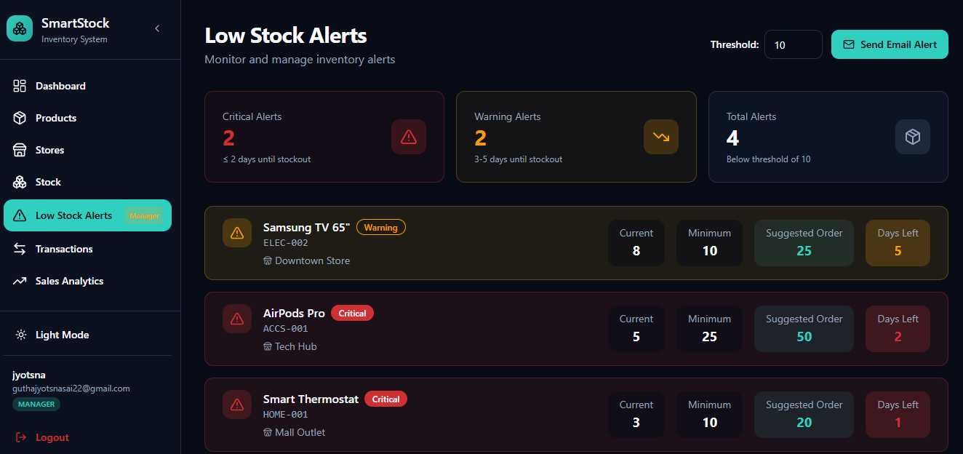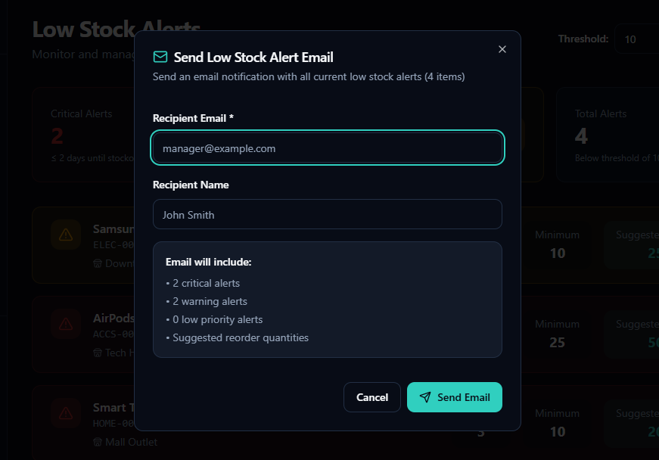

Step 8: Adding Stock Transactions
This screen shows stock-in and stock-out transactions being recorded for proper tracking of inventory levels.
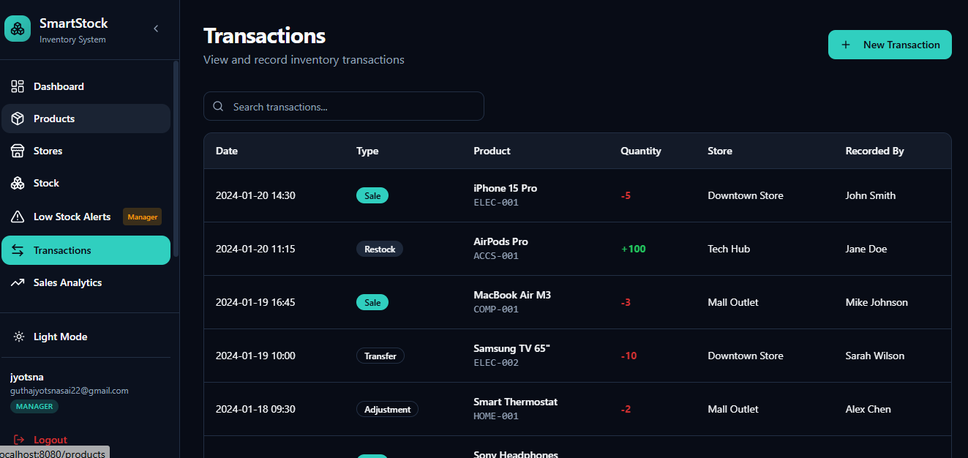Step 9: Revenue Trend Graph
This screenshot shows the Revenue Trend bar chart, representing monthly revenue comparison based on product sales.

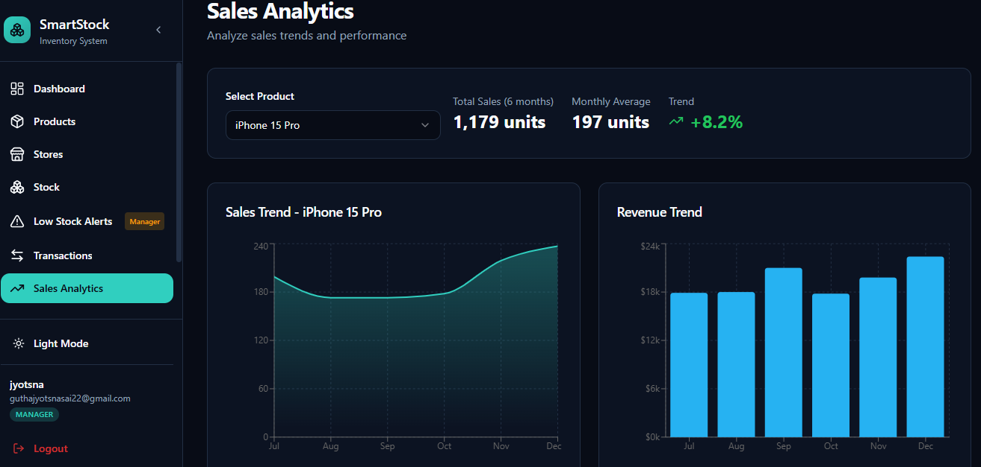

7. Challenges Faced
• Data Availability – Accessing real-world retail inventory datasets with complete sales and demand details was challenging, so an open-source store sales time-series dataset was used.
• Data Quality Issues – The dataset contained missing values, irregular time intervals, and inconsistent sales records, requiring extensive data cleaning and preprocessing.
• Demand Forecasting Accuracy – Achieving accurate demand predictions was difficult due to seasonal variations, promotions, and sudden changes in customer buying behavior.
• Model Selection – Selecting the most suitable ML model for sales forecasting required experimentation before finalizing XGBoost for better performance and accuracy.
• Integration Complexity – Integrating the XGBoost ML model with Django REST APIs, MySQL database, and React frontend required careful handling of data flow and synchronization.
• Performance Optimization – Ensuring fast API responses and efficient ML predictions without slowing down the system was a key challenge.
• Frontend Visualization – Presenting inventory status and forecast results clearly using graphs required multiple iterations for better clarity and usability.
• Backend–Frontend Communication – Managing smooth data exchange between Django REST backend and React (Vite) frontend needed proper API design and testing.
• Time Management – Completing data preprocessing, model training, frontend development, backend integration, and testing within the 8-week internship period was demanding.
• Testing & Validation – Validating demand forecasts across different products and time periods required repeated testing and evaluation.

8. Learnings & Skills Acquired

• Machine Learning Skills – Gained practical experience in demand forecasting using the XGBoost algorithm on time-series sales data.
• Data Preprocessing & Feature Engineering – Learned how to clean sales data, handle missing values, and create time-based features for ML models.
• Time-Series Analysis – Developed an understanding of sales trends, seasonality, and demand patterns in retail inventory systems.
• Backend Development – Strengthened skills in building RESTful APIs using Django REST Framework and integrating ML models into backend services.
• Frontend Development – Enhanced React (Vite) skills by creating dashboards to display inventory data and forecast results.
• Database Management – Improved knowledge of designing and managing relational databases using MySQL for inventory and sales data.
• Data Visualization – Learned to generate and interpret graphs using Matplotlib for sales trends and demand forecasts.
• Problem-Solving – Improved ability to handle real-world issues such as data inconsistency, integration bugs, and performance bottlenecks.
• Testing & Debugging – Gained experience in API testing, unit testing, and end-to-end system validation.
• Project Management – Learned to plan tasks, meet deadlines, and manage a complete AI-based project within a fixed timeline.

9. Testimonials from team
Team Member 1:
“This project helped me understand how machine learning models like XGBoost can be applied to real-world retail sales forecasting and inventory optimization.”
Team Member 2:
“I gained hands-on experience in data preprocessing, backend API development, and integrating ML models with a web application.”
Team Member 3:
“SmartStock improved my understanding of full-stack development and taught me how to connect frontend, backend, and machine learning components effectively.”
Team Member 4:
“The project enhanced my skills in data analysis, visualization, and problem-solving while working on a real-world inventory management use case.”
Team Member 5:
"The project improved my knowledge in NLP, data preprocessing, and visualization techniques, and also boosted my confidence in handling real-world AI applications."

10. Conclusion

The SmartStock Inventory Optimization project successfully delivered an AI-based system for forecasting product demand and improving inventory management in retail stores. By combining machine learning (XGBoost), time-series sales analysis, Django REST APIs, React-based dashboards, and MySQL database management, the system enables data-driven inventory decisions. The project enhanced technical knowledge, analytical thinking, and practical development skills while providing a scalable and efficient solution to common retail inventory challenges.

11. Acknowledgements
I would like to express my sincere gratitude to Infosys for providing me the opportunity to work on the SmartStock Inventory Optimization project and gain valuable hands-on experience in AI, machine learning, and full-stack development.
I am especially thankful to my mentor Shakthi Gopalakrishnan, for her continuous guidance, support, and valuable feedback throughout the internship. Her mentorship played a crucial role in overcoming technical challenges and improving my understanding of real-world applications.
I would also like to thank my team members for their cooperation, support, and collaborative efforts in successfully completing this project.
Finally, I extend my appreciation to everyone who contributed directly or indirectly to my learning and the successful completion of this internship.

